Section 1: Write an application that accepts two numbers, divides the first number with second number and display the result. Hint: you need to handle ArithmeticException which is thrown when there is an attempt to divide a number by zero.

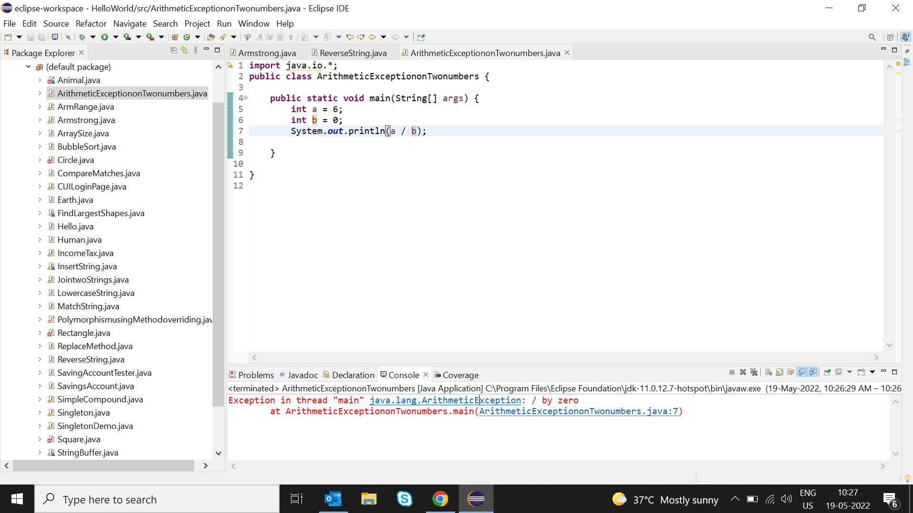

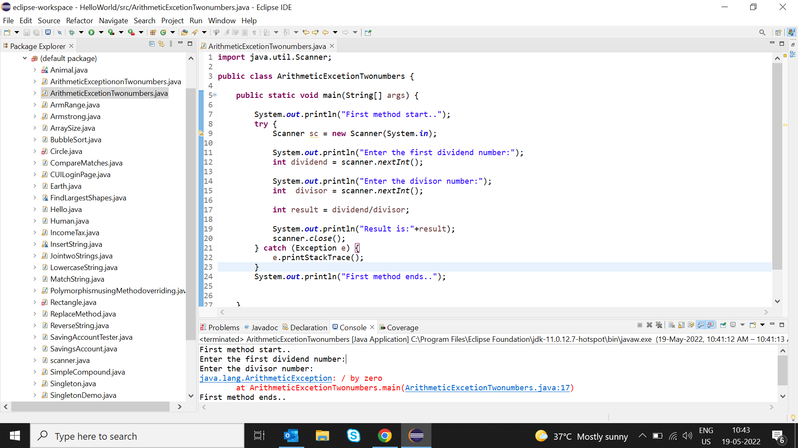

Section2: Carrying forward with the above problem, handle ArithmeticException by raising UnsupportedOperationException as a solution.

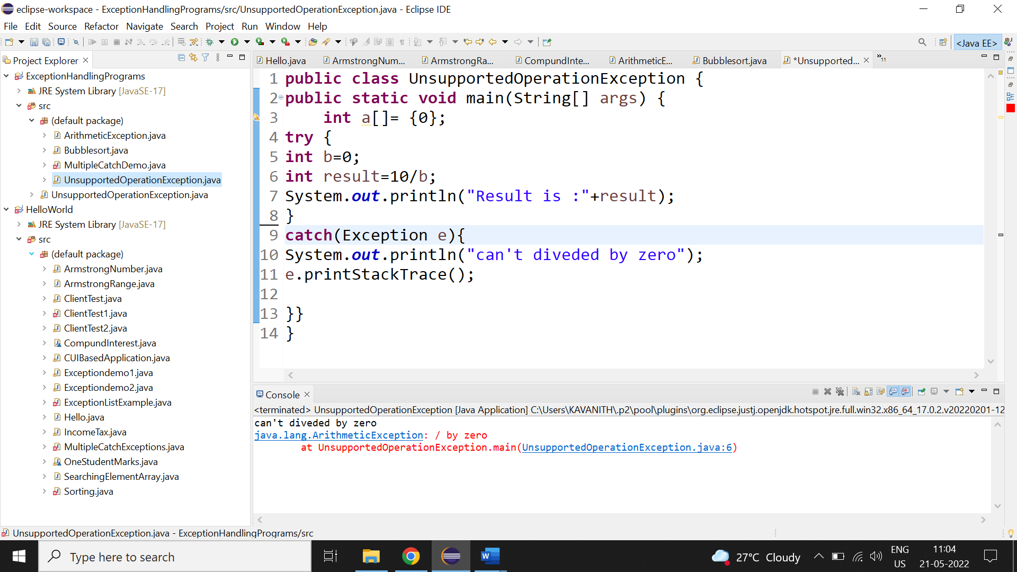

Section 3: Write an application to perform withdraw functionality on a SavingsAccount object. Point to note:

1. Raise InSufficientBalanceException if you are trying to withdraw more than balance or when you balance is zero. E.g. if you balance is 2000 and if yor are trying to withdraw 2100 or if you balance is 0 and you are trying to withdraw positive value.

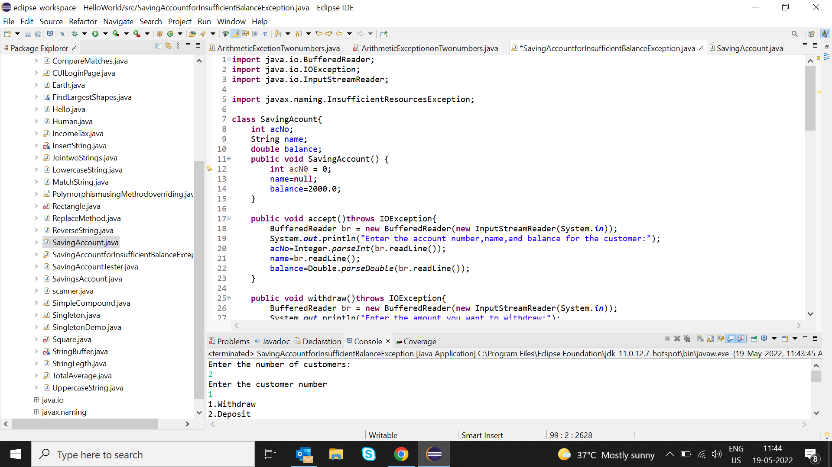

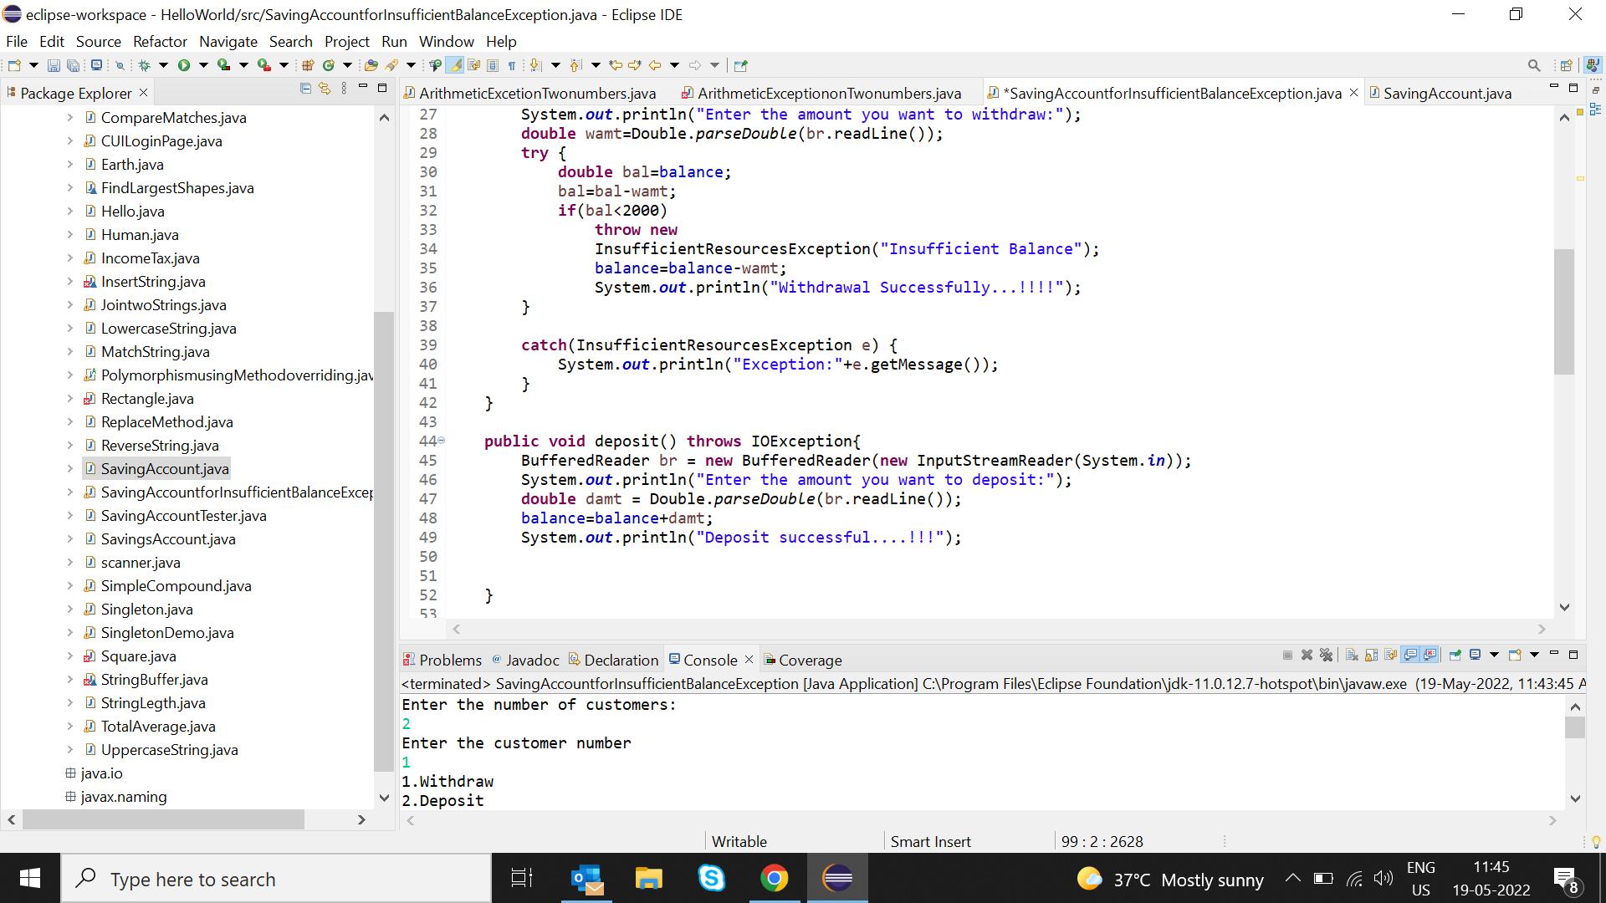

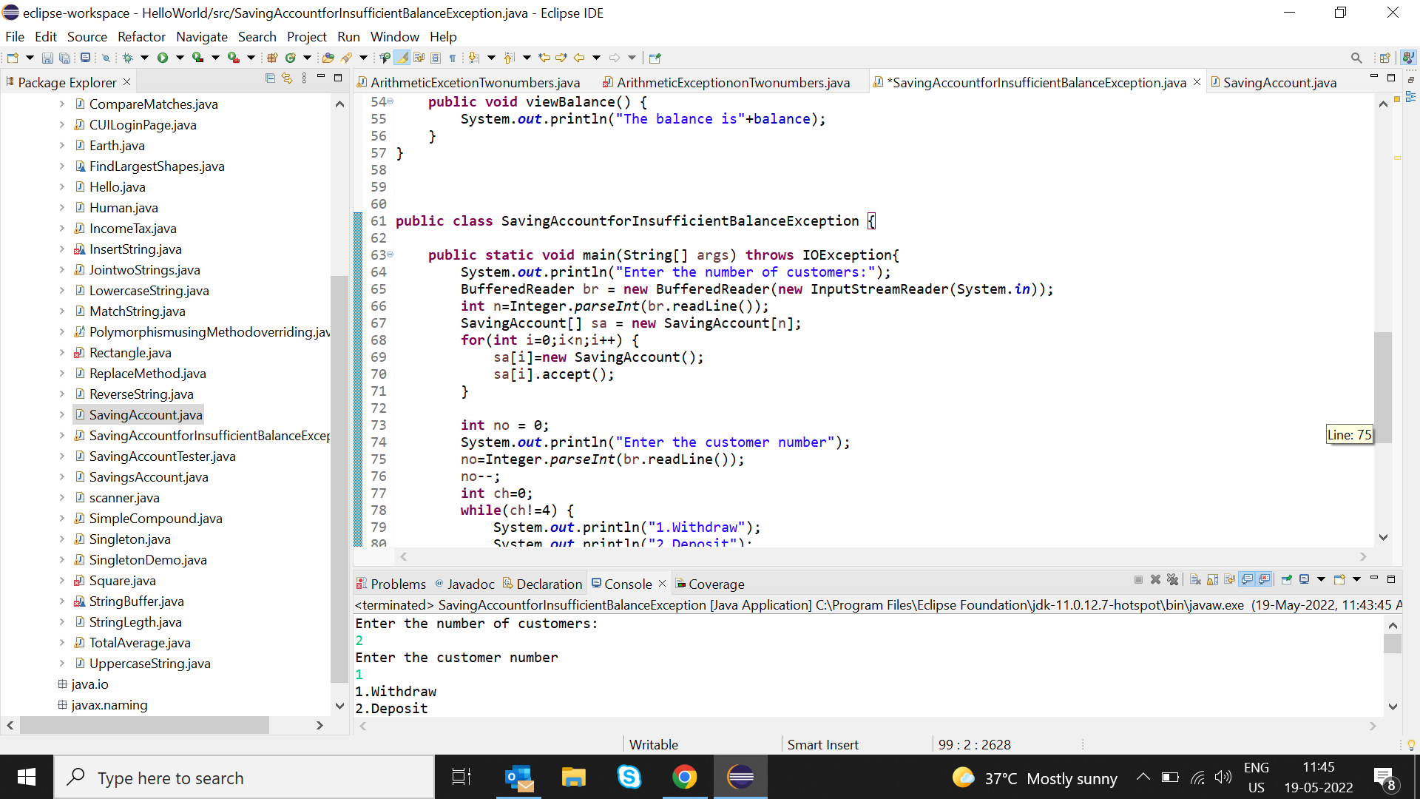

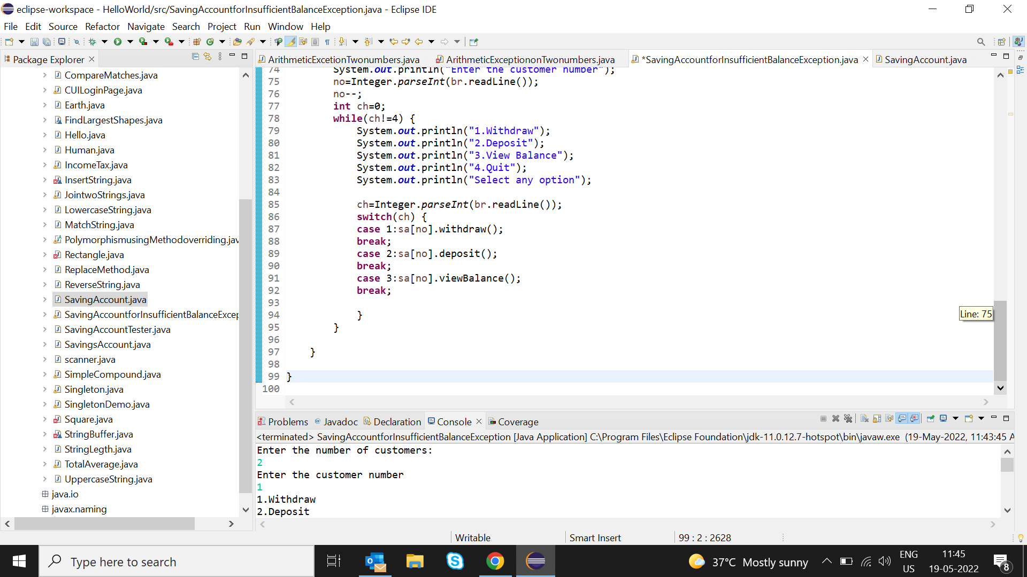

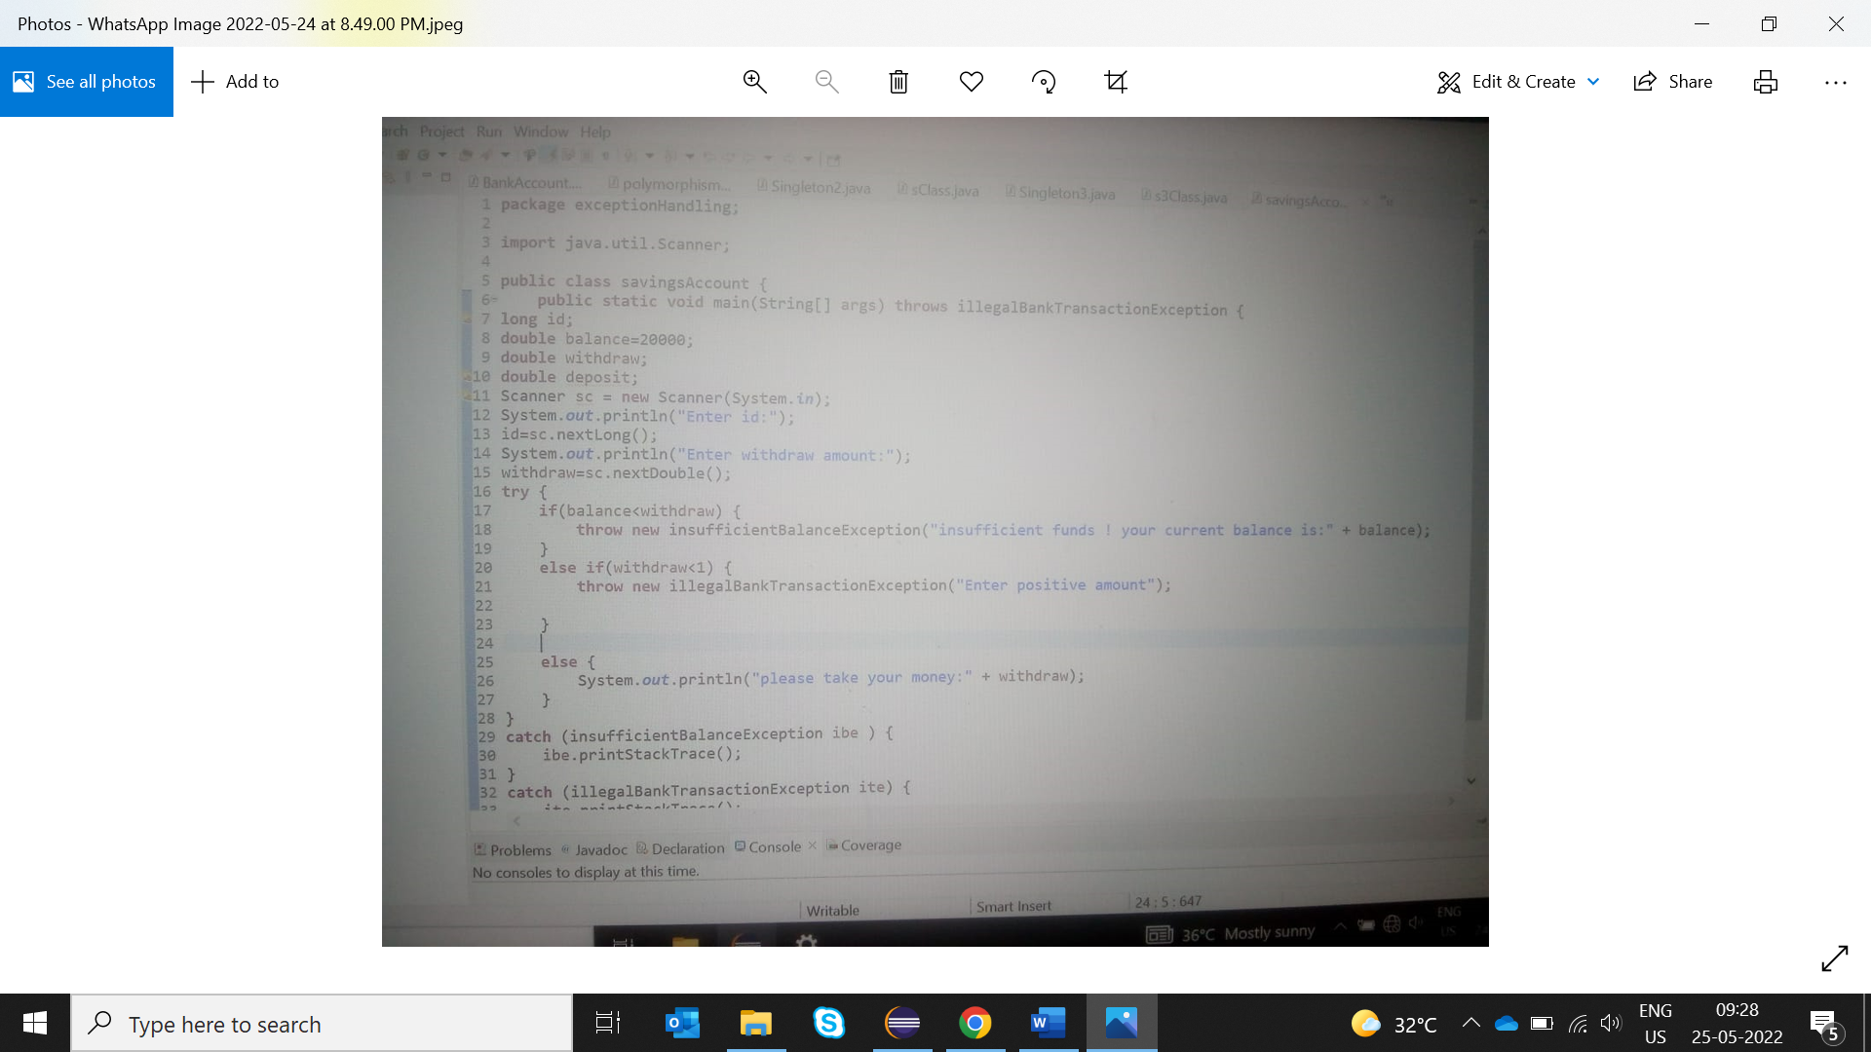

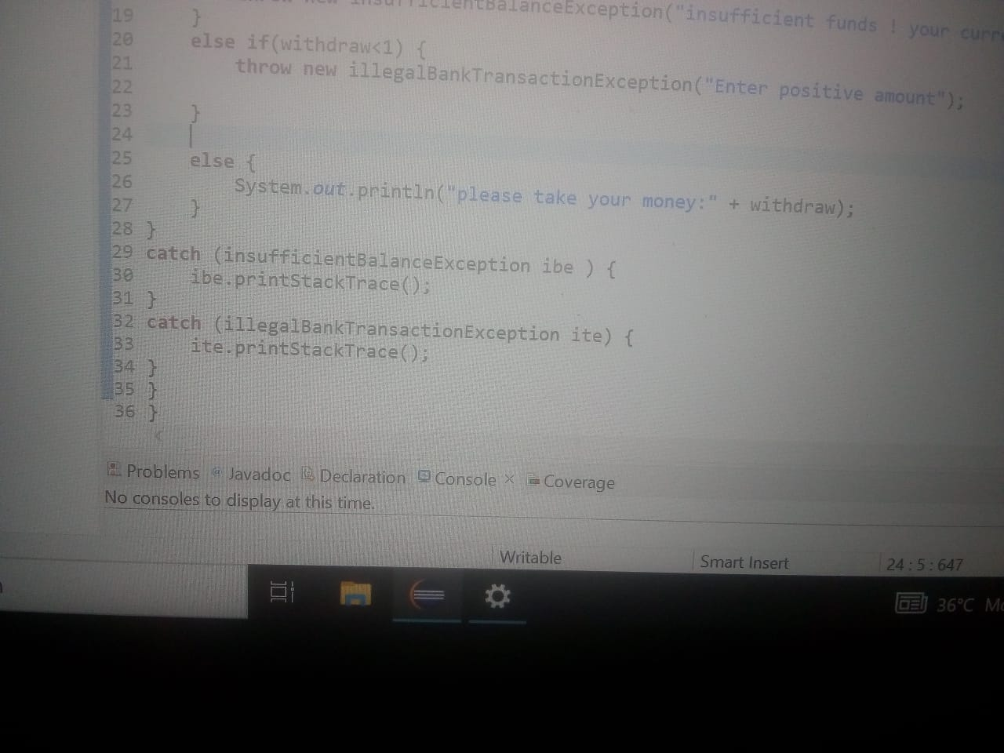

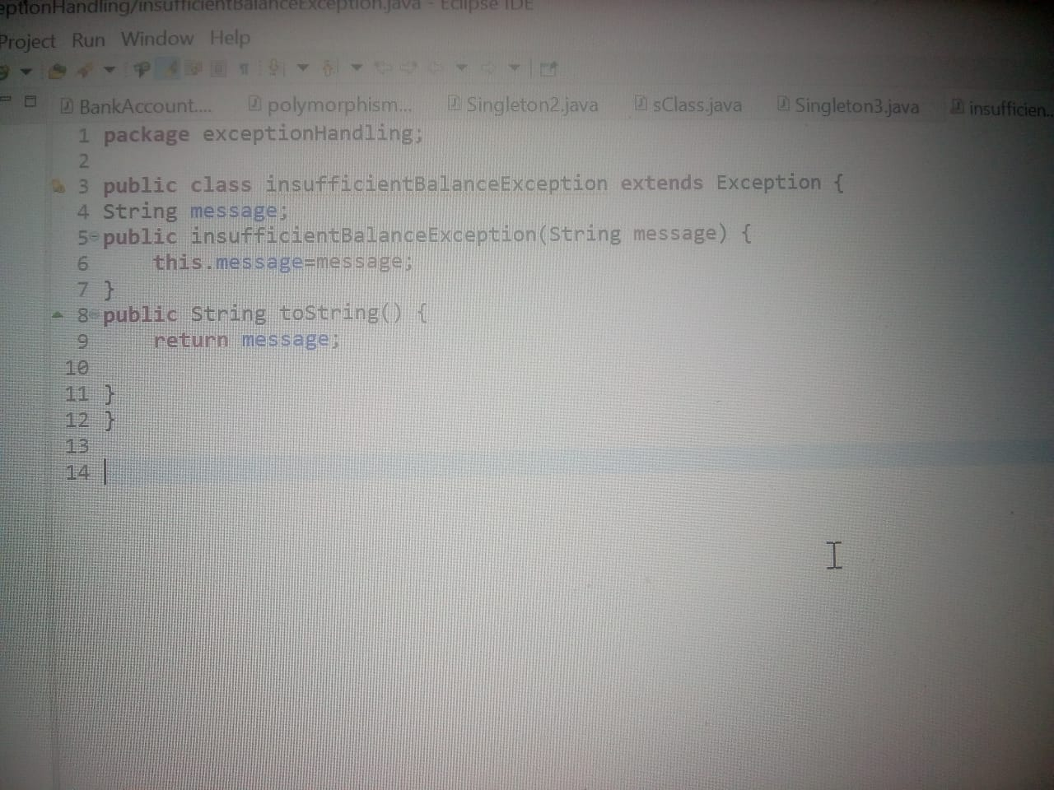

Raise IllegalBankTransactionException if you are trying to withdraw a negative value from your balance. E.g. if you try to withdraw a negative value savingAccount.withdraw(-1000);

